**If statement**

The syntax of the (if statement) is as follows:

Curly braces can also be used especially if the body contains more than one statement:

if (condition) {

Statement;

}

if (condition)

Statement;

The above is used with one statement

int x = 5;

if (x == 4) // condition is always evaluated to boolean

System.out.println("this will not be executed as x is not equals to 4");

System.out.println ("executed whether the condition true or false");

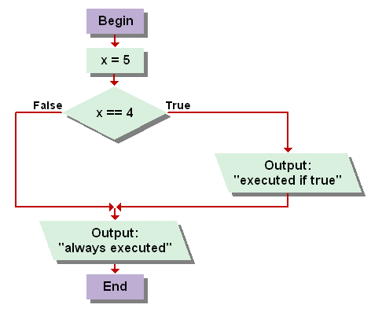

Diamond

shape

The above code can also be written as:

int x = 5;

if (x == 4){

System.out.println("executed if true ");

}

System.out.println (“always executed”);

The program will not go through the true branch if x is not equal to 4 as the condition is evaluated to false and no statement is executed through the false rute, but the last output “always..” is executed in all cases.

If x was 4, then the program will follow the true branch and both output will be executed.

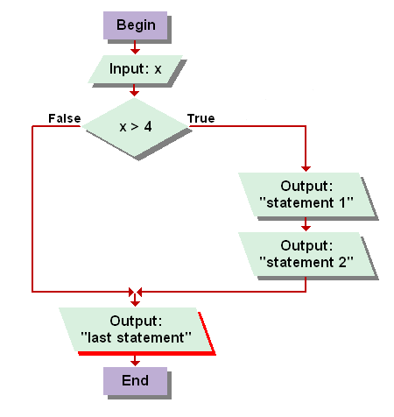If we want the proram to execute more than one statement, then the curly braces must be used. Or otherwise (without the braces) only the first statement is executed.

Example:

System.out.println ("Enter a value: ");

int x = scan.nextInt();

if (x > 4)

{

System.out.println("statement 1");

System.out.println("statement 2");

}

System.out.println("last statement");

If x > 4 (follow the true branch)

Output: statement 1, statement 2 and last statement

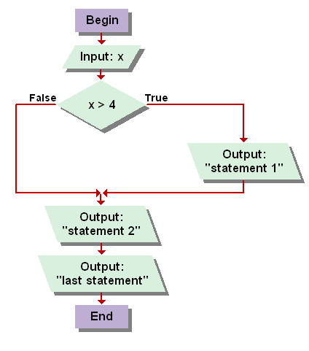if x not > 4 (follow the false branch)

Output: last statement

If we remove the curly braces from the above program:

System.out.println ("Enter a value: ");

int x = scan.nextInt();

if (x > 4)

System.out.println ("statement 1");

System.out.println ("statement 2");

System.out.println ("last statement");

If x > 4 (will pass through the first statement)

Output: statement 1, statement 2, and last statement

If x not > 4 (will not pass through the first statement)

Output: statement 2, and last statement